Lec 5 Create Landing Page functionality

* Now here in this we are going to give an action to the buttons where on the click the various tasks will be performed
* Now for this we will be writing java script inside the html file itself
* First of all we need to import a JQuery Library for this
* 
* Now we will be giving action to the button Join meeting button
* So now we will be creating a join meeting class in the Join Meeting Button
* 
* Now after creating the class now in script portion we will be writing a function for this
* 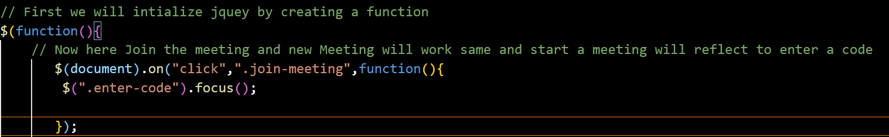
* Here enter-code class is created in the button where we are going to enter the code now on clicking Koin meeting there will be a function called which has a class enter-code is tobe focused.
* Now we will enter the code and then press the join button where class is join-action and then int the variable join_value the value written in the class enter-code is stored.
* 

By concatenating **window.location.origin** with **"?meetingID="** and **join_value**, the code creates a URL with the current origin and the **join_value** as a query parameter. This URL can be used to redirect the user to the meeting page or perform further actions related to joining the meeting.

For example, if the current page's URL is **https://example.com**, and **join_value** is **12345**, the resulting **meetingUrl** would be **https://example.com?meetingID=12345**.

* 
* Now above all steps where for if you have the meeting code but lets say if you do not had the meeting code and yoy click on the new meeting then..on clicking it the random number will be generated and stored in the variable which is fur the concated to the meeting Url
* 